# Lesson 4, Step 1 Design Skills Portfolio Planning

## Interior Design Fundamentals: Building Your Design Skills Portfolio

Documentation sits at the heart of professional interior design. As you explore this field, you'll find that how you capture and showcase your work matters just as much as the designs themselves. This module will guide you through effective design documentation and portfolio creation—skills that will highlight your creative talents and give you an edge when job hunting or meeting with potential clients. The documentation methods covered here will directly benefit your upcoming space analysis work, where your ability to record observations will shape your design choices.

## 1. Portfolio Development: Strategic Approaches for Interior Design

### Understanding Portfolio Purpose and Audience

Consider your portfolio as your design narrative—one that shifts depending on who's viewing it. Much like choosing different outfits for different occasions, your portfolio needs various versions for different audiences. A bathroom renovation might fascinate a potential client but might require additional technical details to interest an employer. Let's look at how to customize your portfolio for best results:

* **Client-Focused**: Demonstrates your problem-solving abilities and aesthetic sense that matches client preferences
* **Professional Development**: Shows the evolution of your skills and approach over time
* **Industry Networking**: Presents your unique design perspective to potential employers or collaborators

**Try This before planning your portfolio structure:** Ask yourself:

* Who's the intended audience for my portfolio?
* What do they need to see about my capabilities?
* Which projects will resonate most with this specific audience?
* What distinctive story do I want to tell about my design approach?

Jot down your three main audience priorities on a sticky note for easy reference.

### Portfolio Communication Goals

Your portfolio should convey several key aspects of your abilities. When someone browses your work, they should quickly grasp your design sensibility, technical skills, and problem-solving methods. It's not simply about displaying attractive spaces—it's about showing the thinking behind those spaces and your ability to bring them to life. Your portfolio should highlight:

* **Design Thinking**: Your problem-solving process and solution development
* **Technical Skills**: Your mastery of various interior design tools and techniques
* **Visual Communication**: Your ability to present ideas visually
* **Professional Awareness**: Your grasp of industry standards and practices

With these goals in mind, your portfolio becomes much more than pretty pictures—it becomes a door-opener for opportunities.

**Try This when exploring professional design work:** Find three examples of interior design portfolios (online, in books, or from professionals) and examine them from an audience perspective. For each one:

1. Figure out the likely main audience (clients, academic reviewers, employers)
2. Spot which elements work best for that audience
3. Think about how the same work might be shown differently for another audience

### Portfolio Presentation Techniques

How you present your work can elevate good design into an unforgettable impression. Imagine walking into a beautifully arranged showroom versus a messy storage room—both might have the same furniture, but your experience would be completely different. Similarly, thoughtful presentation transforms your design work from merely interesting to truly captivating. Here's how to create that showroom experience in your portfolio:

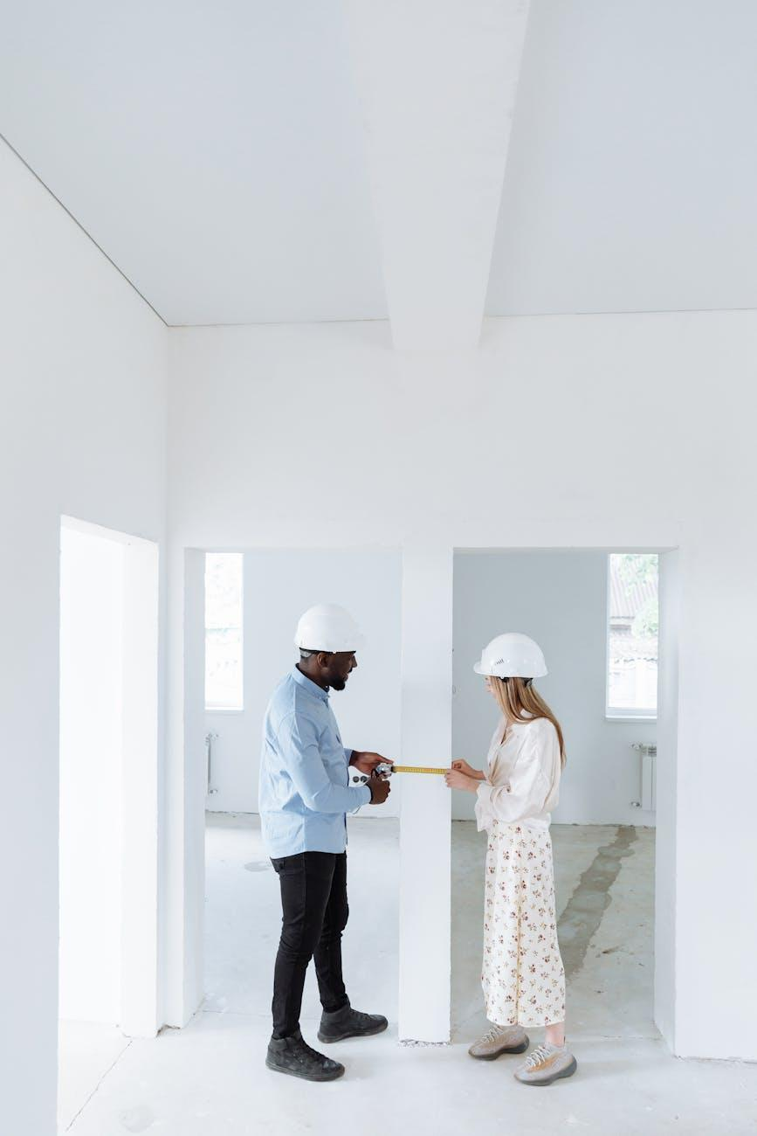

Fig.2 (Thirdman on [Pexels](https://www.pexels.com/photo/8470802/), 2025) Effective portfolio presentation combines compelling visuals with professional annotations that explain your design rationale and process.

1. **Organize your portfolio pages into clear sections:**

* Process documentation (research, analysis, development)
* Design solutions (final concepts, layouts, specifications)
* Technical skills demonstration (drawings, models, material selections)
* Before/after comparisons (when applicable)

1. **Include professional annotations** that explain your design decisions using industry terminology and showcase your analytical thinking
2. **Create a visual hierarchy** that guides viewers through your design journey from initial concepts to final solutions
3. **Apply professional layout principles:**

* Consistent margins and grid systems
* Thoughtful typography choices
* Strategic use of white space
* Cohesive colour scheme that complements your work

**Try This with a sample portfolio page:** Can someone unfamiliar with your work understand your design intent and process within 30 seconds of viewing your portfolio? If not, you might need to refine your presentation. The way you arrange your portfolio serves two purposes—it showcases your designs while demonstrating your ability to communicate clearly and think strategically, qualities that clients and employers greatly appreciate. Ask a friend for their 30-second impression and note what caught their eye first.

## 2. Documentation for Design: Beyond Basic Record-Keeping

You might question why documentation matters so much in design. In reality, documentation isn't just keeping records—it's creating value:

### Documentation as Communication Tool

Good documentation ensures everyone grasps exactly what you're aiming to achieve:

* **Client Communication**: Shows clients you understand their needs and have thoughtful solutions
* **Collaboration Support**: Makes working with contractors, architects, and other designers smooth
* **Design Clarity**: Helps avoid costly misunderstandings about your proposals
* **Managing Expectations**: Creates a record of agreements and decisions that maintains client satisfaction

### Documentation for Project Management

When handling multiple aspects of a design project, solid documentation becomes invaluable. It's like having a reliable assistant who remembers everything and keeps you on track during the creative process. Those detailed notes about a client's preference for matte finishes or measurements of that awkward corner can save hours of rework and prevent expensive mistakes. Here's how documentation supports your project management:

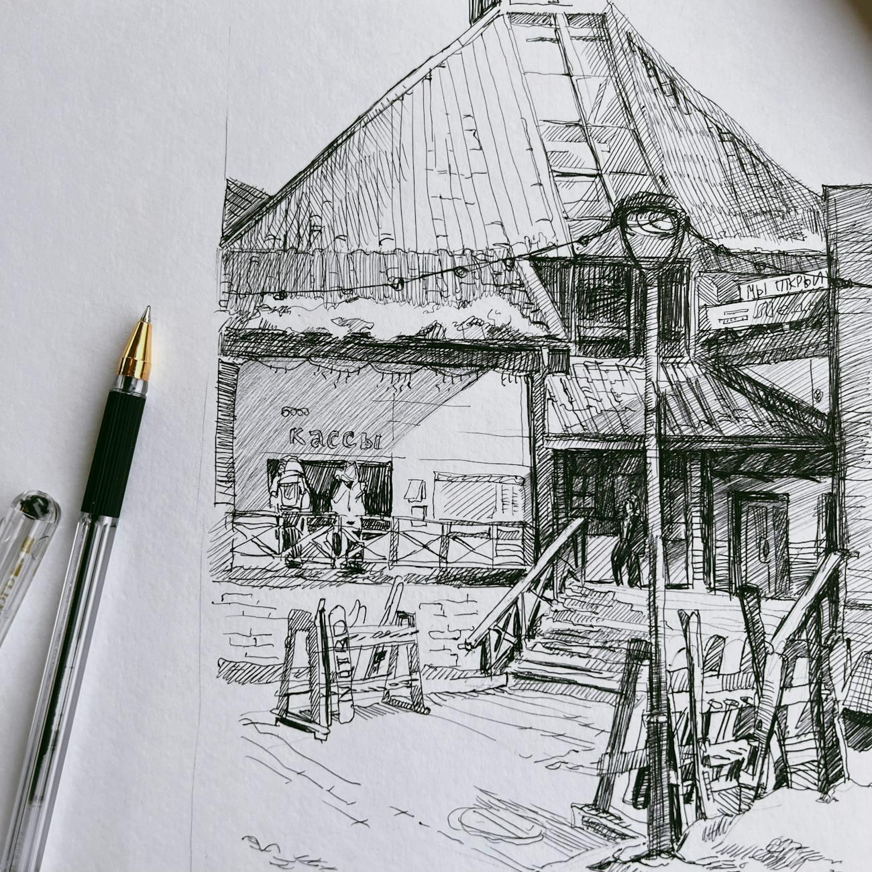

Fig.3 (Sofya Borboris on [Pexels](https://www.pexels.com/photo/12261025/), 2025) Thorough on-site documentation combines physical measurements, digital tools, and material references to create a comprehensive record that prevents costly mistakes.

* **Decision Tracking**: Helps you recall why you made certain choices (especially helpful when clients change direction!)
* **Progress Monitoring**: Illustrates your journey from initial concepts to refined solutions
* **Knowledge Management**: Builds a resource you can reference for similar projects
* **Project Planning**: Helps break complex projects into manageable stages with realistic timeframes

### Documentation as Reflective Practice

The act of documenting actually improves your design thinking. Have you noticed how explaining something to someone else often clarifies your own understanding? Documentation works similarly. When you sketch that initial concept and add notes about your inspiration, you're not just recording information—you're actively processing and refining your ideas. This reflective aspect of documentation is where much of your growth as a designer happens:

* **Design Evolution**: Captures those breakthrough moments when ideas transform
* **Problem-Solving Evidence**: Shows how you tackle challenges creatively
* **Learning Documentation**: Creates a record of your growing expertise to reflect on
* **Research Application**: Shows how your research findings directly shape your design decisions

## Project Documentation Framework

For each design project, try to document these key elements. Think of this structure as your design story outline—each element contributes to a complete narrative explaining not just what you designed, but why and how you designed it. Whether documenting a small home project or a complex commercial space, this approach ensures you capture the full scope of your design thinking:

1. **Project Context**: Client needs, site conditions, constraints
2. **Research Findings**: Precedents, inspirations, relevant standards
3. **Concept Development**: Initial ideas and their evolution
4. **Design Decisions**: Key choices and their reasoning
5. **Process Work**: Sketches, iterations, explorations
6. **Technical Considerations**: Basic awareness of regulations and standards that might affect your design
7. **Final Presentation**: Polished communication of your solution
8. **Reflection**: Insights gained and lessons learned

When you document thoroughly, you're not just creating a record—you're building a resource that shows your professionalism and attention to detail.

**Try This during your next visit to a public environment:** Pick a public space you visit regularly (such as a café, library, or retail store) and document it using the framework above. Focus on recording your observations and initial thoughts about how the space functions. Create a structured log with:

* Dated entries
* Clearly labeled sections
* Annotated sketches explaining key observations
* Brief notes on how the space might be affected by basic regulations (accessibility, safety)

## 3. Portfolio Content Selection: Strategic Curation

### Content Selection Framework

The most impressive portfolios aren't those that show everything—they're ones that show the right things:

* **Relevance Assessment**: Question if each piece truly supports your goals
* **Audience Alignment**: Select content that will connect with your intended viewers
* **Narrative Contribution**: Choose elements that strengthen your portfolio's overall story
* **Quality Filtering**: Include only work that represents your best abilities

### Balancing Process and Outcomes

Finding the right mix of content requires careful balance:

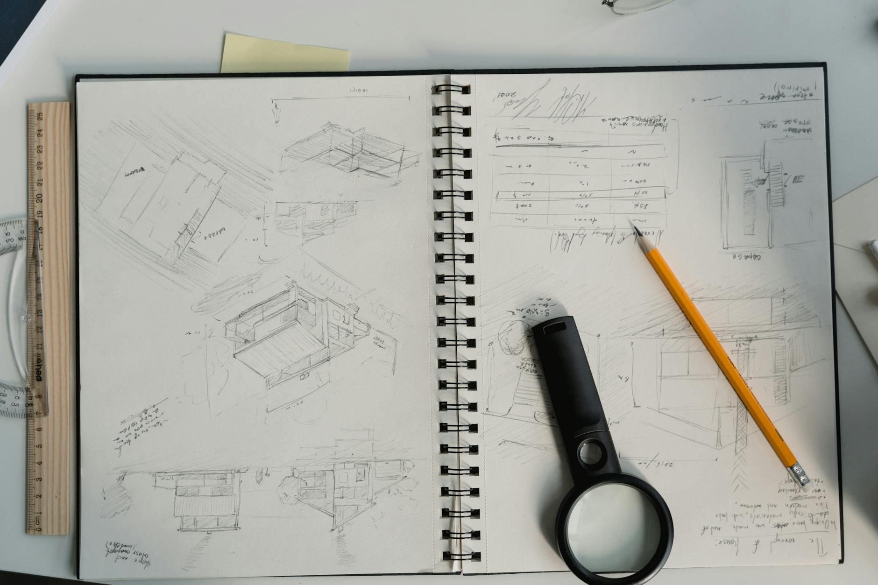

Fig.4 (Tima Miroshnichenko on [Pexels](https://www.pexels.com/photo/6615233/), 2025) Effective portfolios balance process documentation with polished outcomes, showing both your creative journey and technical execution abilities.

* **Process Documentation**: Reveals your thinking and development (Your tutors and some clients enjoy seeing this)
* **Finished Work**: Shows what you can actually deliver (clients especially value this)
* **Technical Details**: Demonstrates you understand how designs get implemented (contractors and employers need this)
* **Conceptual Thinking**: Showcases your creativity and problem-solving (important for standing out)

### Content Selection Criteria

When deciding what makes the cut, ask yourself:

* Does this piece showcase a skill I want to be hired for?
* Does it reveal something unique about my approach?
* Is it relevant to the type of work I want to do more of?
* Does it fit into the overall story I'm telling?
* Would I be proud to show this to my design hero?
* Does it demonstrate my ability to apply research to inform design decisions?

These questions help you create a focused portfolio that opens doors to opportunities you actually want.

**Try This when evaluating your design projects:** From a recent design project or exercise, pick three elements that would be most valuable to include in a portfolio. For each element:

1. Identify which audience would find this most compelling (clients, educators, employers)
2. Specify what skill or capability it demonstrates
3. Create a professional layout for presenting it, including:

* A descriptive heading
* A brief context paragraph
* High-quality visuals with proper resolution
* Annotations explaining your design thinking

Rank your selections from strongest to weakest and consider what would strengthen your weakest piece.

## 4. Portfolio Quality Standards: Professional Presentation

### Interior Design Portfolio Essentials

A portfolio that opens doors demonstrates:

1. **Complete Design Narrative**: Takes viewers on a journey from challenge to solution
2. **Process Transparency**: Shows the thinking behind your decisions
3. **Technical Understanding**: Proves you understand the practical realities of implementation
4. **Visual Communication**: Presents information in a way that's both beautiful and clear
5. **Professional Awareness**: Demonstrates you understand industry expectations

### Quality Assessment Considerations

Before you share your portfolio, evaluate it through these lenses:

* **Clarity of Communication**: Would someone get your design intent immediately?
* **Visual Consistency**: Does your presentation have a cohesive, polished look?
* **Process Documentation**: Can viewers understand how you arrived at your solutions?
* **Technical Accuracy**: Are your representations precise and to scale?
* **Professional Presentation**: Does everything look like it belongs in a design studio?

### Technical Drawing Basics

While you'll develop more refined technical drawing skills in the HNC program, your portfolio can already show some fundamental understanding of:

**[Figure Fig 5: No suitable image found]**

[Image: A designer's workspace showing hand-drawn floor plans alongside digital drawings on a tablet, with measuring tools visible. Caption: "Fig 5: Even beginning designers can demonstrate technical awareness through basic scaled drawings that show spatial relationships and key measurements."]

* **Scale**: Basic ability to draw to scale using simple tools
* **Line Types**: Understanding of fundamental line weights and styles (solid lines for visible elements, dashed for hidden elements)
* **Floor Plans**: Basic grasp of how floor plans represent spaces
* **Annotations**: Clear labeling of key elements in your drawings

### Connecting to your HNC success

The documentation skills you're developing now will prove essential when you start analyzing spaces in depth. When you can systematically capture observations about spatial qualities, traffic flow, and functional zones, you'll gather concrete information to fuel your design decisions. The documentation habits you're building today will give you a rich foundation of spatial understanding that makes your design solutions both creative and practical.